WATER JUG PROBLEM

Aim
To write a Python program to solve the Water Jug Problem using Artificial Intelligence.

Objective
- To obtain the required amount of water using two jugs.
- To apply the concept of State Space Search.
- To find the solution step by step.

Algorithm
- Start the program.
- Take two jugs of capacities 4 L and 3 L.
- Fill the 4 L jug.
- Pour water from the 4 L jug into the 3 L jug until it is full.
- Empty the 3 L jug.
- Pour the remaining water from the 4 L jug into the 3 L jug.
- Fill the 4 L jug again.
- Pour water into the 3 L jug until it becomes full.
- Now, the 4 L jug contains exactly 2 L of water.
- Stop.

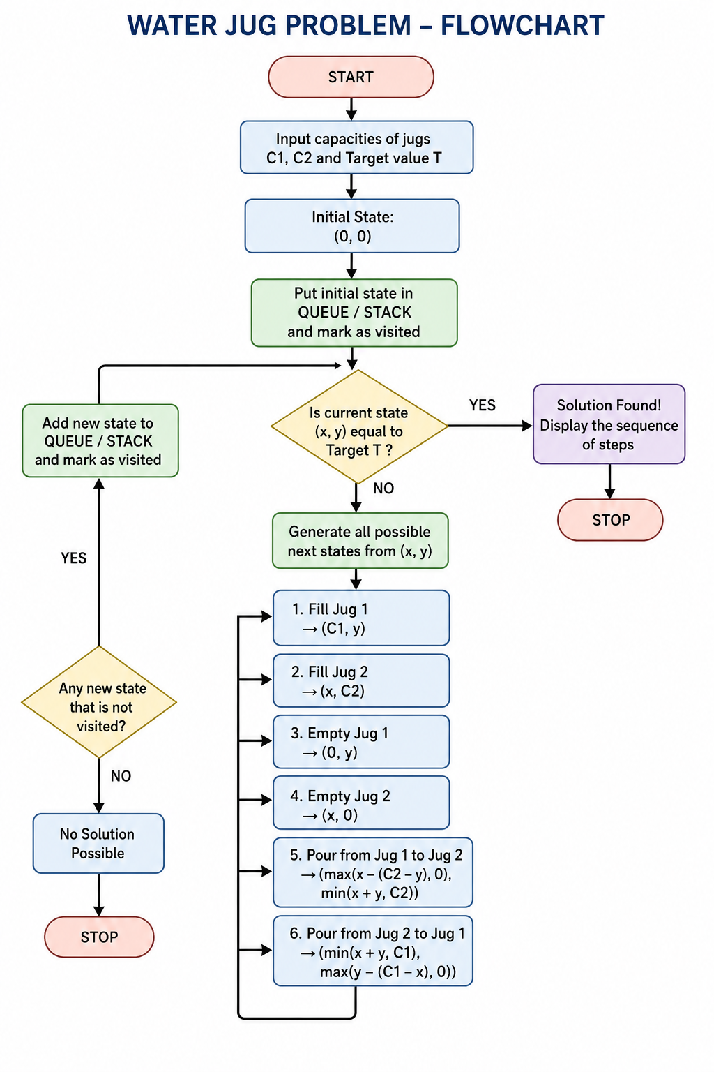

SOURCE CODE

# Water Jug Problem

jug4 = 0
jug3 = 0

print("Initial State:", (jug4, jug3))

jug4 = 4
print("Fill 4L Jug:", (jug4, jug3))

jug4, jug3 = 1, 3
print("Pour 4L -> 3L:", (jug4, jug3))

jug3 = 0
print("Empty 3L Jug:", (jug4, jug3))

jug4, jug3 = 0, 1
print("Pour Remaining Water:", (jug4, jug3))

jug4 = 4
print("Fill 4L Jug Again:", (jug4, jug3))

jug4, jug3 = 2, 3
print("Pour 4L -> 3L:", (jug4, jug3))

print("\nGoal Achieved: 2 Litres in 4L Jug")

OUTPUT

